

the

eas.

al.

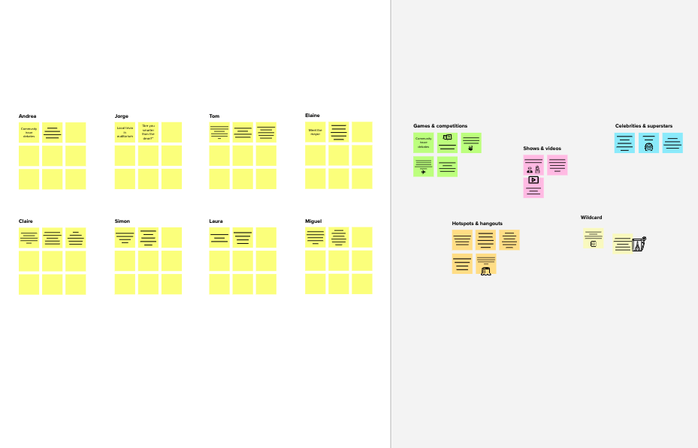

**Need some inspiration?**

See a finished version of this template to kickstart your work.

[**Open example**](https://app.mural.co/template/e5a93b7b-49f2-48c9-afd7-a635d860eba6/93f1b98d-b2d2-4695-8e85-7e9c0d2fd9b9)

[**Share template feedback**](https://muralco.typeform.com/to/CiqaHVat?typeform-source=app.mural.co)

**10 minutes** to prepare

**1 hour** to collaborate

**2-8 people** recommended

**Brainstorm**

**& idea prioritization**

Use this template in your own brainstorming sessions so your team can unleash their imagination and start shaping concepts even if you're not sitting in the same room.



**1**



**4**

**Prioritize**

Your team should all be on the same page about what's important moving forward. Place your ideas on this grid to determine which ideas are important and which are feasible.

**After you collaborate**

You can export the mural as an image or pdf to share with members of your company who might find it helpful.

**20 minutes**

**Quick add-ons**

**A Share the mural**

**Share a view link** to the mural with stakeholders to keep them in the loop about the outcomes of the session.

**B Export the mural**

Export a copy of the mural as a PNG or PDF to attach to emails, include in slides, or save in your drive.

Application

**Organization**

**Containment zone**

**Keep moving forward**

Alerting Notification

Free Treatment

24/7

Monitoring affected zone

**Strategy blueprint**

Define the components of a new idea or strategy.

Containment zone Alerting Application

Fund from various source

Import medicine

[**Open the template**](https://app.mural.co/template/e95f612a-f72a-4772-bc48-545aaa04e0c9/984865a6-0a96-4472-a48d-47639307b3ca)

**Customer experience journey map**

Keep User Updated

Herbal Remedy

Safety Precaution to be Followed

Government containment zone

**Importance**

If each of these tasks could get done without any difficulty or cost, which would have the most positive impact?

Understand customer needs, motivations, and obstacles for an experience.

[**Open the template**](https://app.mural.co/template/b7114010-3a67-4d63-a51d-6f2cedc9633f/c1b465ab-57af-4624-8faf-ebb312edc0eb)

**Strengths, weaknesses, opportunities & threats**

Identify strengths, weaknesses, opportunities, and threats (SWOT) to develop a plan.

[**Open the template**](https://app.mural.co/template/6a062671-89ee-4b76-9409-2603d8b098be/ca270343-1d54-4952-9d8c-fbc303ffd0f2)

[**Share template feedback**](https://muralco.typeform.com/to/CiqaHVat?typeform-source=app.mural.co)

**TIP**

Participants can use their cursors to point at where sticky notes should go on the grid. The facilitator can confirm the spot by using the laser pointer holding the **H key** on the keyboard.

**Feasibility**

Regardless of their importance, which tasks are more feasible than others? (Cost, time, effort, complexity, etc.)

**3**

**Group ideas**

Take turns sharing your ideas while clustering similar or related notes as you go. In the last 10 minutes, give each cluster a sentence-like label. If a cluster is bigger than six sticky notes, try and see if you and break it up into smaller sub-groups.

**20 minutes**

Health Care Department

**TIP**

Add customizable tags to sticky notes to make it easier to find, browse, organize, and categorize important ideas as themes within your mural.

Non- Governmrntal Organization

Containment zone Alerting Application

Template

Following negative tests per discharge policy

Containment plan and start on mitigation activities

Follow up the hospital contacts

The containment operation shall be deemed to be 28 days

FINANCE DEPARTMENT

**SANDHIYA S**

**VIJAYALAKSHMI R**

**SWETHA P**

**SWETHA M**

**PRIYADHARSHINI M**



**Define your problem statement**

What problem are you trying to solve? Frame your problem as a How Might We statement. This will be focus of your brainstorm.

**2**

**Brainstorm**

Write down any ideas that come to mind that address your problem statement.

**10 minutes**

**5 minutes**

Alerting keep user

Notification updated

Your Sample is Collected at Lab

24/7

Free Treatment

Free Camp

Herbal Remedy

Monitoring affected zone

Import medicine

Containment zone Alerting application

Health Care Department

Non- Governmrntal Organization

Government can utilise the application and alert the people when they are entering to a containment zone

Application Changes your zone to COVID+ve (RED)

& initiate contact tracing

Keep People updated

Lab uploads the test results to ICMR Portal. This is mandatory for Application to know, if you have tested +ve

Funds from Voluntary

various Sources

Citizens Group

**Key rules of brainstorming**

To run an smooth and productive session

Stay in topic.

Encourage wild id

Defer judgment.

Listen to others.

Go for volume.

If possible, be visu

**C Learn how to use the facilitation tools**

Use the Facilitation Superpowers to run a happy and productive session.

[**Open article**](https://support.mural.co/en/articles/2113740-facilitation-superpowers)

**B Set the goal**

Think about the problem you'll be focusing on solving in the brainstorming session.

**A Team gathering**

Define who should participate in the session and send an invite. Share relevant information or pre-work ahead.

**Before you collaborate**

A little bit of preparation goes a long way with this session. Here’s what you need to do to get going.

**10 minutes**

**PROBLEM**

John is a social worker, who needs to know how many people are there in the containment zone so that he can help those people

Safety Precaution to be Followed

Direct control of ministry

Government containment zone

**TIP**

You can select a sticky note and hit the pencil [switch to sketch] icon to start drawing!

|  |  |
| --- | --- |
|  |  |
|  |  |